

## VISVESVARAYA TECHNOLOGICAL UNIVERSITY

**“JNANA SANGAMA” , BELAGAVI-590018, KARNATAKA**



**A Mini Project Report On**

S

***“CAR EMI CALCULATOR”***

**Submitted in the partial fulfillment of the requirement for the completion of Mobile Application Development(18CSMP68) and award of degree of**

**BACHELOR OF ENGINEERING IN**

**INFORMATION SCIENCE AND ENGINEERING**

**Submitted By**

**PRAKRUTHI B S 1VA19CS036**

**KAUSHIK C 1VA19CS022**

**ANANYA N T 1VA19CS006**

**NAVYA B 1VA19CS032**

**AMEENODDIN 1VA19CS004**

**Under the Guidance of**

**Mr. Pradeep Kumar K Mrs. Salma Itagi**

**Assistant Professor Assistant Professor**

 **Dept. of CSE, SVIT Dept. of CSE, SVIT**

**DEPARTMENT OF INFORMATION SCIENCE AND ENGINEERING**

**SAI VIDYA INSTITUTE OF TECHNOLOGY**

**(Affiliated to Visvesvaraya Technological University, Belagavi | Recognized by Govt. of Karnataka | Approved by AICTE, New Delhi)**

**RAJANUKUNTE, BENGALURU – 560 064**

**2021-22**

S

**SAI VIDYA INSTITUTE OF TECHNOLOGY**

**Rajanukunte, Bengaluru- 560 064**

**DEPARTMENT OF INFORMATION SCIENCE AND ENGINEERING**



**CERTIFICATE**

Certified that the Mini project work entitled *“****CAR EMI CALCULATOR****”* carried out by **Ms. PRAKRUTHI B S(1VA19CS036), Mr. KAUHSIK C(1VA19CS022), Ms. ANANYA N T(1VA19CS006), Ms. NAVYA B(1VA19CS032), Mr. AMMENODIN(1VA19CS004)** bonafide students of **SAI VIDYA INSTITUTE OF TECHNOLOGY**,

Bengaluru, in partial fulfillment for the award of Bachelor of Engineering in Computer Science and Engineering of **VISVESVARAYA TECHNOLOGICAL UNIVERSITY**, Belagavi during the year **2021-22.** It is certified that all corrections/suggestions indicated for Internal Assessment have been incorporated in the Report deposited in the departmental library. The project report has been approved as it satisfies the academic requirements in respect of mini-Project work prescribed for the **Mobile Application Development(18CSMP68).**

**Mr.Pradeep Kumar K**

Assistant Professor, Dept of CS&E, SVIT

**Dr. Shantakumar B Patil**

HOD

Dept of CS&E, SVIT

**Dr. H S Ramesh Babu**

Principal



**External Viva:**

**Name Signature**

**1.**

**2.**



## ACKNOWLEDGEMENT

The completion of Project brings the sense of satisfaction, but it is never completed without thanking the persons who are all responsible for its successful completion. First and foremost, we wish to express our deep sincere feelings of gratitude to our Institution, **Sai Vidya Institute of Technology**, for providing us an opportunity to do our education.

We would like to thank the **Management** and **Prof. M R Holla**, Director, Sai Vidya Institute of Technology for providing the facilities.

We extend our deepest sense of sincere gratitude to **Dr H S Ramesh Babu**, Principal, Sai Vidya Institute of Technology, Bengaluru, for having permitted us to carry out the project work on ***Car EMI Calculator.***

We are thankful to **Prof. A M Padma Reddy**, Professor and Dean (Student affairs), Department of Computer Science and Engineering, Sai Vidya Institute of Technology, for his constant support and motivation.

We express our heartfelt sincere gratitude to **Dr. Shantakumar B Patil,** Professor and HOD, Department of Computer Science and Engineering, Sai Vidya Institute of Technology, Bengaluru, for his valuable suggestions and support.

We express my special in-depth, heartfelt, sincere gratitude to **Prof. Pradeep Kumar K**, Asst. Prof, Dept of CSE and **Prof. Salma Itagi**, Asst.Prof,Dept of CSE, Sai Vidya Institute of Technology, Bengaluru for their constant support in completing the project.

Finally, we would like to thank all the Teaching, Technical faculty and supporting staff members of Department of Computer Science and Engineering, Sai Vidya Institute of Technology, Bengaluru, for their support.

**PRAKRUTHI B S 1VA19CS036**

**KAUSHIK C 1VA19CS022**

**ANANYA N T 1VA19CS006**

**NAVYA B 1VA19CS032**

**AMEENODDIN 1VA19CS004**

# ABSTRACT

Nowadays, people are racing to achieve a comfortable standard of living. They work hard to support their families and also to the satisfaction of his own life. It is not surprising if we see many who can afford to buy houses and cars with full payment for the common interest.

However not all are able to do so, those who have large families are more likely to pay in monthly installments. For example, for car EMI payment. Therefore, our group has developed an application that will facilitate their affairs that cannot afford for the full installment for the car itself. We developed an application called “Car Emi Calculator” to reduce their problem.

The purpose of this application is to help people who want to purchase a car by using monthly installments. With this application also, people will find out if they can afford their dream car using this user-friendly car EMI calculator. by using this car EMI calculator, user just need to insert total amount of car, down payment, interest rate and EMI period then the application will calculate to the user how much user need to pay monthly within a certain period of time. And this application also helps the users to calculate the loan amount when the car price and the down payment fields are filled.

# Table of Contents

|  |  |  |
| --- | --- | --- |
| **Sl.no** | **Chapter name** | **Page no** |
| 1. | Introduction | 1-3 |
| 2. | System Requirement | 4 |
| 3. | Proposed System | 5-9 |
| 4. | Snapshots | 10-11 |
| 5. | Summary | 12 |
| 6. | Conclusion | 13 |

**CHAPTER 1**

# INTRODUCTION

### What is mobile application development?

Mobile app development is the act or process by which a mobile app is developed for mobile devices, such as personal digital assistants, enterprise digital assistants or mobile phones. These applications can be pre-installed on phones during manufacturing platforms, or delivered as web applications using server-side or client-side processing (e.g., JavaScript) to provide an "application- like" experience within a Web browser.

Application software developers also must consider a long array of screen sizes, hardware specifications, and configurations because of intense competition in mobile software and changes within each of the platforms. Mobile app developmenthas been steadily growing, in revenues and jobs created. A 2013 analyst report estimates there are 529,000 direct app economy jobs within the EU then 28 members (including the UK), 60 percent of which are mobile app developers.

As part of the development process, mobile user interface (UI) design is also essential in the creation of mobile apps. Mobile UI considers constraints, contexts, screen, input, and mobility as outlines for design. The user is often the focus of interaction with their device, and the interface entails components of both hardwareand software. User input allows for the users to manipulate a system, and device's output allows the system to indicate the effects of the users' manipulation.

Mobile UI design constraints include limited attention and form factors, such as a mobile device's screen size for a user's hand(s). Mobile UI contexts signal cues from user activity, such as location and scheduling that can be shown from user interactions within a mobile app. Overall, mobile UI design's goal is mainly for an understandable, user-friendly interface. The UI of mobile apps should: consider users' limited attention, minimize keystrokes, and be task-oriented with a minimum set of functions. This functionality is supported by mobile enterprise application platforms or integrated development environments (IDEs).

### DESIGNING

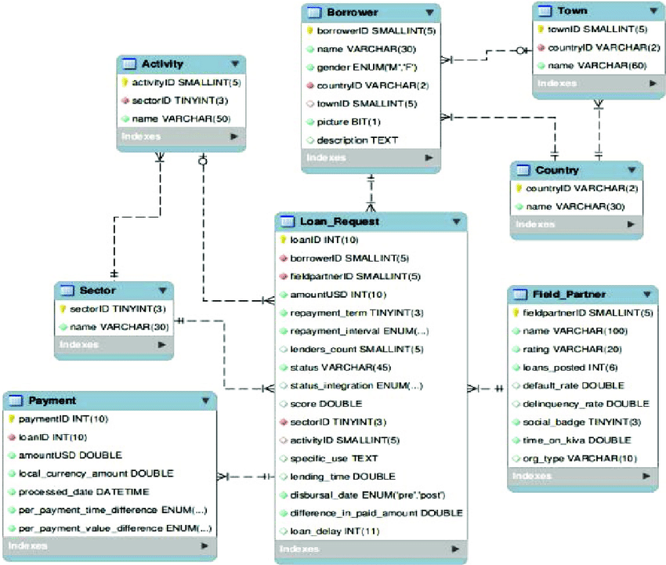

* 1. **PROBLEM STATEMENT**

Create an AIDL service that calculates Car Loan EMI. The formula to calculate EMI is E = P * (r(1+r) n)/((1+r) n -1)

where E = The EMI payable on the car loan amount P = The Car loan Principal Amount

r = The interest rate value computed on a monthly basis

n = The loan tenure in the form of months the down payment amount has to be deducted from the principal amount paid towards buying the Car.

Develop an application that makes use of this AIDL service to calculate the EMI. This application should have five Edit Text to read the Car Price, Down Payment, Loan Amount, Interest Rate, Loan Term (in months) and a button named as “CALCULATE EMI”. On click of this button, the result should be shown in a Text View. And also another button named as “CALCULATE LOAN AMOUNT”. On click of this button, the calculated loan amount is displayed. Also, calculate the EMI by varying the Loan Term and Interest Rate values.

### OBJECTIVE

The aim is to Automate its existing manual system with the help of computerized equipment and full-fledged computer software, fulfilling their requirements, so that their valuable data/information can be stored for a longer period with easy accessing and manipulation of the same. The project describes how to manage for good performance and better services for the clients.

EMI calculator is a java and xml based architectural android application project, demonstrating the functionalities required to the user to answer questions.

**CHAPTER 2**

# SYSTEM REQUIREMENTS

### SOFTWARE REQUIREMENTS

* + - Operating system: ANY OS (Recommended: Windows 7 or above)
    - Program editor: Android Studio
    - Browser: Preferable Google Chrome or Mozilla Firefox
    - Programming Language: Java and XML

### HARDWARE REQUIREMENTS

* + - CPU: Pentium IV or higher.
    - Memory (Primary): 512 MB, 1 GB or above
    - Hard Disk: 40 GB, 80GB, 160GB or above
    - RAM: 8GB or above

# CHAPTER 3

**PROPOSED SYSTEM**

The fundamental idea behind our project is to make a product that would offer new aspects of learning. We wanted to create a tool that fits into modern age, but still stays true to the concepts of studying.

### The java functionalities used in proposed system of Car EMI Calculator app are:

**MainActivity.java**

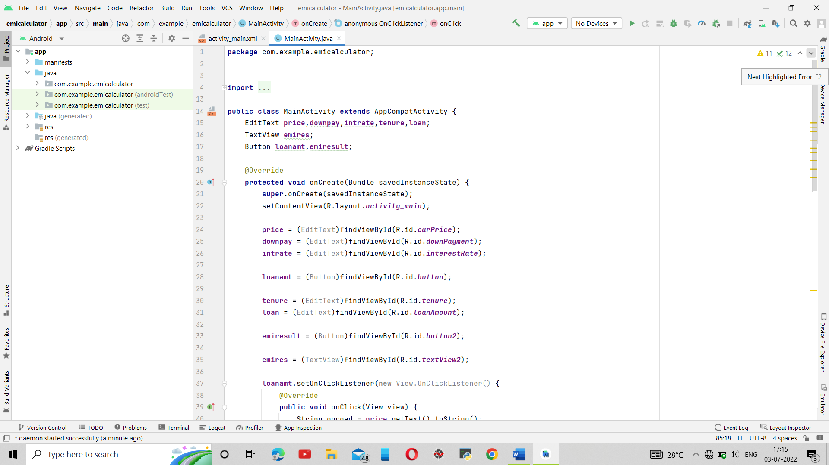

### 

### 

**3.2 The XML file**

**activity_main.xml**

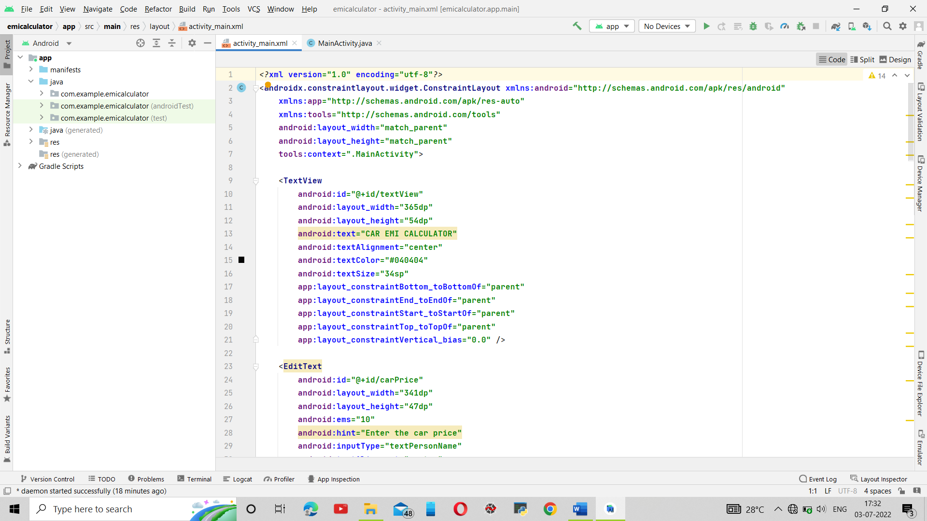

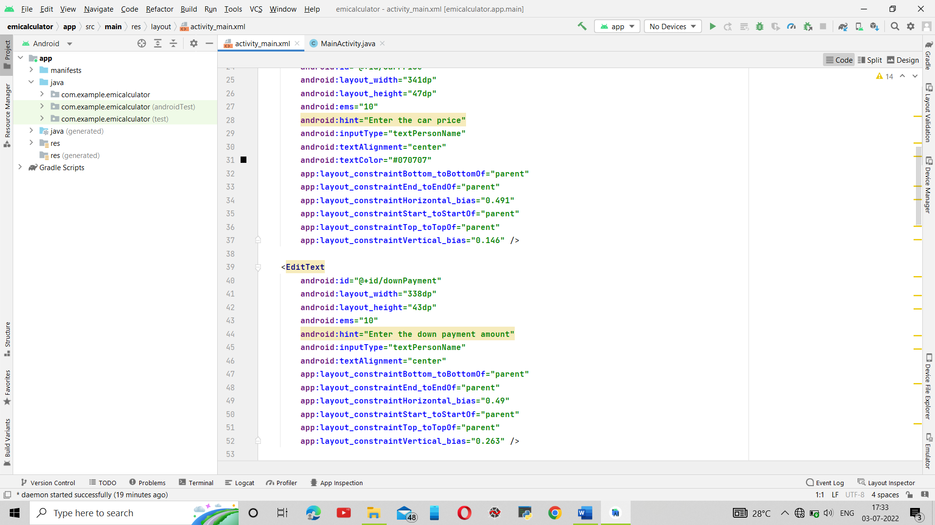

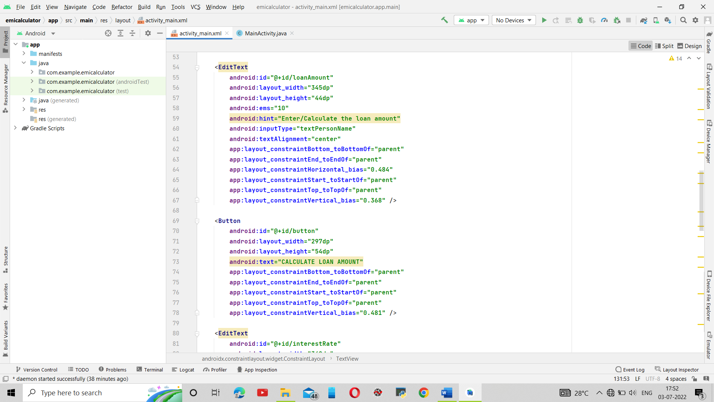

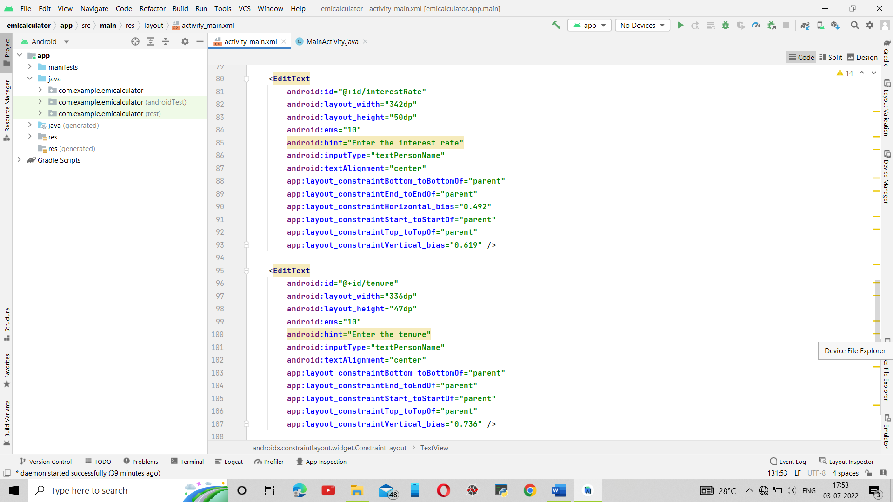

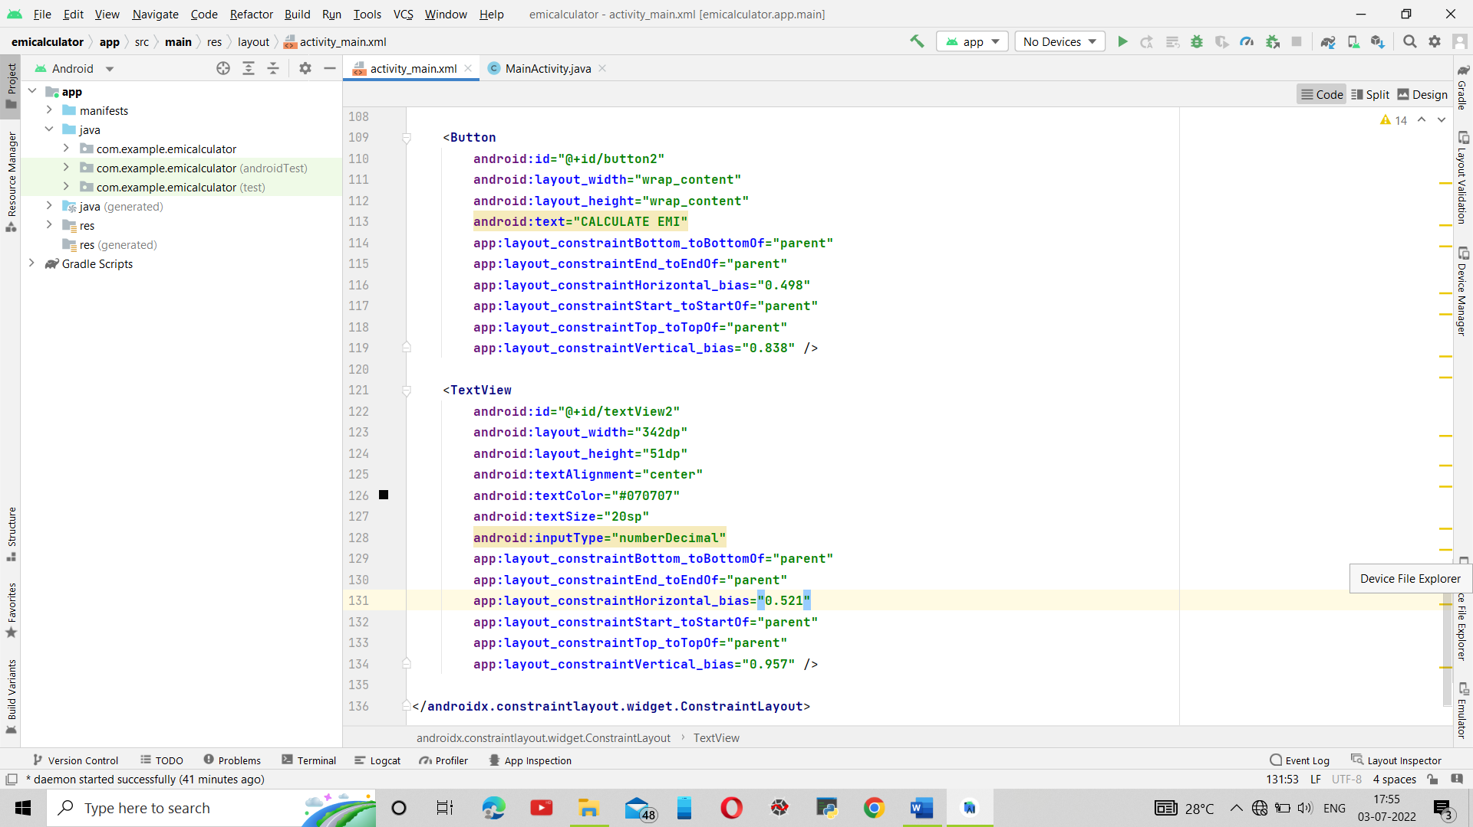

* 1. **AndroidManifest.xml**

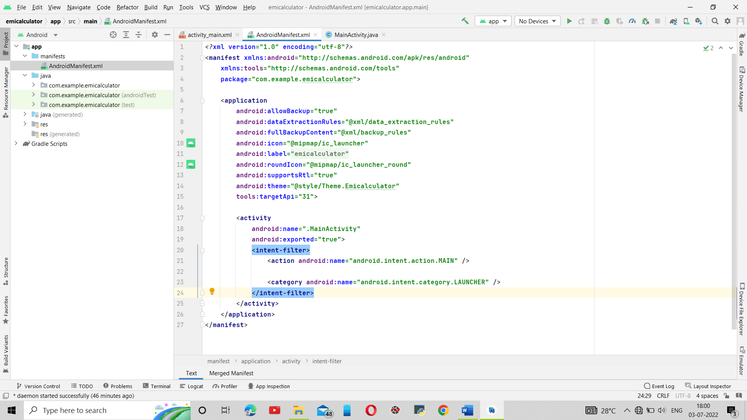

**CHAPTER 4**

# SNAPSHOTS

# 

# 

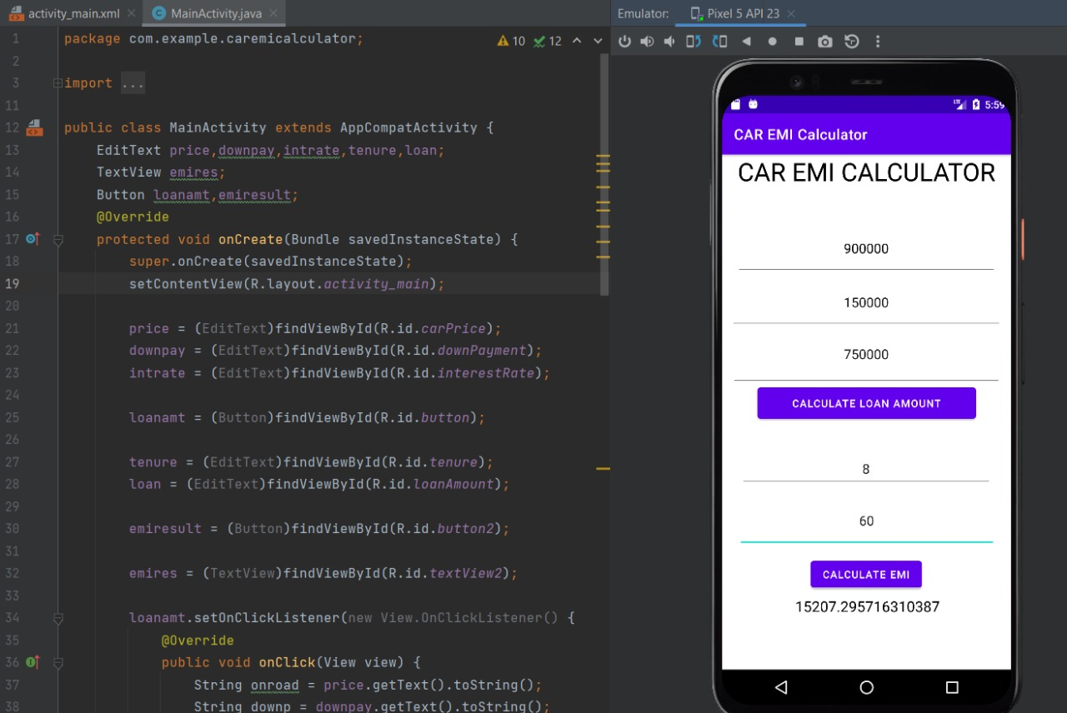

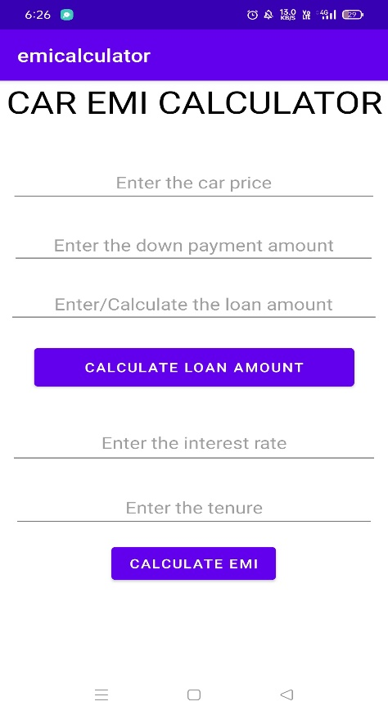 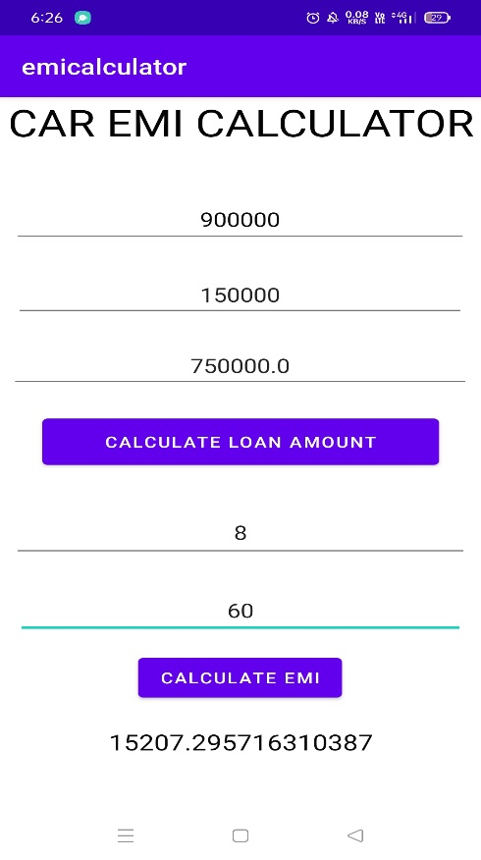

#### SUMMARY

We have developed a easy to use system for any type of user. It is easy to implement and requires no training to use. It is error-proof and does large amount of work in the background. Thus, the system aids to simplify the processes used by developer and player as well as reduce operational costs like paper, pen etc the primary concerns of all businesses.

# CONCLUSION

The principal loan amount minus the one-time processing fee is disbursed to the borrower’s

bank account.

All the EMI payments in this standard EMI scheme consists of the principal amount and the interest

The Annual Percentage Rate (APR) of the loan (which is the total cost of the loan) is usually lower in an EMI scheme.

The down payment is lower in an EMI scheme.

it is advisable to opt for an EMI scheme only if you can afford to make an adavance EMI payment in addition to the down payment (on a car) at the time of loan disbursal. Otherwise, it is better to settle for an Later EMI scheme. Use an online personal loan/c EMI calculator to find out the total cost of your loan for both the EMI schemes and choose one that costs you less.

**BIBILOGRAPHY**

#### https://[www.youtube.com/](http://www.youtube.com/)

* https://[www.google.com/](http://www.google.com/)

#### https://[www.geeksforgeeks.org/](http://www.geeksforgeeks.org/)